Ashutosh Kumar Kaushik

Stock Market Analysis

Table of Contents
  - Understanding the Problem Statement
  - Moving Average
  - Linear Regression
  - k-Nearest Neighbors
  - Auto ARIMA
  - Prophet
  - Long Short Term Memory (LSTM)

Understanding the Problem Statement
We’ll dive into the implementation part of this article soon, but first it’s important to establish what we’re aiming to solve. Broadly, stock market analysis is divided into two parts – Fundamental Analysis and Technical Analysis.
- Fundamental Analysis involves analyzing the company’s future profitability on the basis of its current business environment and financial performance.
- Technical Analysis, on the other hand, includes reading the charts and using statistical figures to identify the trends in the stock market.
As you might have guessed, our focus will be on the technical analysis part. We’ll be using a dataset from Quandl (you can find historical data for various stocks here) and for this particular project, I have used the data for ‘Tata Global Beverages’. Time to dive in!

Moving Average

Introduction
‘Average’ is easily one of the most common things we use in our day-to-day lives. For instance, calculating the average marks to determine overall performance, or finding the average temperature of the past few days to get an idea about today’s temperature – these all are routine tasks we do on a regular basis. So this is a good starting point to use on our dataset for making predictions.
The predicted closing price for each day will be the average of a set of previously observed values. Instead of using the simple average, we will be using the moving average technique which uses the latest set of values for each prediction. In other words, for each subsequent step, the predicted values are taken into consideration while removing the oldest observed value from the set. Here is a simple figure that will help you understand this with more clarity.
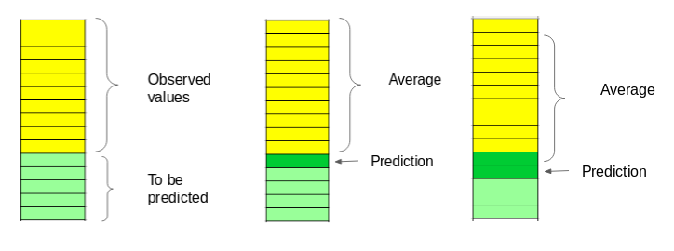
We will implement this technique on our dataset. The first step is to create a dataframe that contains only the Date and Close price columns, then split it into train and validation sets to verify our predictions.

Inference
The RMSE value is close to 105 but the results are not very promising (as you can gather from the plot). The predicted values are of the same range as the observed values in the train set (there is an increasing trend initially and then a slow decrease).
In the next section, we will look at two commonly used machine learning techniques – Linear Regression and kNN, and see how they perform on our stock market data.

Linear Regression

Introduction
The most basic machine learning algorithm that can be implemented on this data is linear regression. The linear regression model returns an equation that determines the relationship between the independent variables and the dependent variable.
The equation for linear regression can be written as: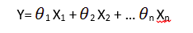
Here, x1, x2,….xn represent the independent variables while the coefficients θ1, θ2, …. θn represent the weights.
For our problem statement, we do not have a set of independent variables. We have only the dates instead. Let us use the date column to extract features like – day, month, year, mon/fri etc. and then fit a linear regression model.

Inference
Linear regression is a simple technique and quite easy to interpret, but there are a few obvious disadvantages. One problem in using regression algorithms is that the model overfits to the date and month column. Instead of taking into account the previous values from the point of prediction, the model will consider the value from the same date a month ago, or the same date/month a year ago.
As seen from the plot above, for January 2016 and January 2017, there was a drop in the stock price. The model has predicted the same for January 2018. A linear regression technique can perform well for problems such as Big Mart sales where the independent features are useful for determining the target value.

k-Nearest Neighbours

Introduction
Another interesting ML algorithm that one can use here is kNN (k nearest neighbours). Based on the independent variables, kNN finds the similarity between new data points and old data points. Let me explain this with a simple example.
Consider the height and age for 11 people. On the basis of given features (‘Age’ and ‘Height’), the table can be represented in a graphical format as shown below:
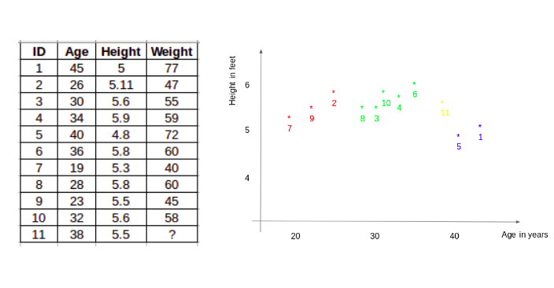
To determine the weight for ID #11, kNN considers the weight of the nearest neighbors of this ID. The weight of ID #11 is predicted to be the average of it’s neighbors. If we consider three neighbours (k=3) for now, the weight for ID#11 would be = (77+72+60)/3 = 69.66 kg.
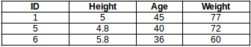

Inference
The RMSE value is almost similar to the linear regression model and the plot shows the same pattern. Like linear regression, kNN also identified a drop in January 2018 since that has been the pattern for the past years. We can safely say that regression algorithms have not performed well on this dataset.

Auto ARIMA

Introduction
ARIMA is a very popular statistical method for time series forecasting. ARIMA models take into account the past values to predict the future values. There are three important parameters in ARIMA:
- p (past values used for forecasting the next value)
- q (past forecast errors used to predict the future values)
- d (order of differencing)
Parameter tuning for ARIMA consumes a lot of time. So we will use auto ARIMA which automatically selects the best combination of (p,q,d) that provides the least error.

Inference
As we saw earlier, an auto ARIMA model uses past data to understand the pattern in the time series. Using these values, the model captured an increasing trend in the series. Although the predictions using this technique are far better than that of the previously implemented machine learning models, these predictions are still not close to the real values.

Prophet

Introduction
There are a number of time series techniques that can be implemented on the stock prediction dataset, but most of these techniques require a lot of data preprocessing before fitting the model. Prophet, designed and pioneered by Facebook, is a time series forecasting library that requires no data preprocessing and is extremely simple to implement. The input for Prophet is a dataframe with two columns: date and target (ds and y).
Prophet tries to capture the seasonality in the past data and works well when the dataset is large.

Inference
Prophet (like most time series forecasting techniques) tries to capture the trend and seasonality from past data. This model usually performs well on time series datasets, but fails to live up to it’s reputation in this case.
As it turns out, stock prices do not have a particular trend or seasonality. It highly depends on what is currently going on in the market and thus the prices rise and fall. Hence forecasting techniques like ARIMA, SARIMA and Prophet would not show good results for this particular problem.

Long Short Term Memory (LSTM)

Introduction
LSTMs are widely used for sequence prediction problems and have proven to be extremely effective. The reason they work so well is because LSTM is able to store past information that is important, and forget the information that is not. LSTM has three gates:
- The input gate: The input gate adds information to the cell state
- The forget gate: It removes the information that is no longer required by the model
- The output gate: Output Gate at LSTM selects the information to be shown as output

Inference
Wow! The LSTM model can be tuned for various parameters such as changing the number of LSTM layers, adding dropout value or increasing the number of epochs. But are the predictions from LSTM enough to identify whether the stock price will increase or decrease? Certainly not!
As I mentioned at the start of the article, stock price is affected by the news about the company and other factors like demonetization or merger/demerger of the companies. There are certain intangible factors as well which can often be impossible to predict beforehand.

End Notes
Time series forecasting is a very intriguing field to work with, as I have realized during my time writing these articles. There is a perception in the community that it’s a complex field, and while there is a grain of truth in there, it’s not so difficult once you get the hang of the basic techniques.
I am interested in finding out how LSTM works on a different kind of time series problem and encourage you to try it out on your own as well

